**A- Listening (12 marks)**

**Name:**

**Exam on unit 6 ⏩ ⏩ ⏩ ⏩ primary 6**

1. **Listen and circle (6 marks)**

|  |  |  |  |
| --- | --- | --- | --- |
| 1 – Is Nadeer thinner than Maher ? | | | |
| *a-* | ***No, he isn't .*** | ***b-*** | *Yes , he is* |
| 2 – How often do you fly abroad ? | | | |
| *a-* | ***Twice a month .*** | ***b-*** | *Once a month .* |
| 3 – When was the concert? | | | |
| *a-* | ***It was last night.*** | ***b-*** | *It was yesterday.* |
| 4 - To Giza. . | | | |
| *a-* | ***Where did you go last April?*** | ***b-*** | *Where did you go last December ?* |
|  |  |  |  |

1. **Listen and complete. (6 marks)**

**Ali : What are you doing ,Kareem?**

**Bassim : I am helping Mr Ali** ➊**............... up the music room .**

**Ali :Can I** ➋**..............you?**

**Bassim : Sure.You can move the**➌ **.....................**

**Ali : Where can I put it ?**

**Bassim: Over there, By the** ➍**...............**

**B- VOCABULARY & STRUCTURE (4 marks)**

1. **choose the correct answer. (4 marks)**

➊ **This song was the........ of the day.**

1. **hit b. hat c. hot d. hut**

➋ **Can he ......... the bike quickly?**

**a. rode b. ride c. rides d. riding**

➌**My sister is ....... up the kitchen.**

**a. eating b.clean c.cleaning d. riding**

➍ **Rana played the drums..........**

**a. bad b. badly c. sad d. slow**

➎ **......... was the soloist?**

**a. How b. What c. When d. Who**

➏ **I’m strong. I can ........... this heavy box.**

**a. leave b.lift c. lifted d. left**

➐ **The teachers wrote and ......... the play.**

**a. performs b. performed c. perform d. is performed**

➑**........ the bag over there.**

**a.puts b. putting c.put d.is put**

**C- Reading (10 marks)**

1. **Circle the odd one out. (6 marks)**

|  |  |  |  |  |  |
| --- | --- | --- | --- | --- | --- |
| 1. | drums | flute | recorder | pencil | ……………… |
| 2. | **fast** | **slowly** | **quick** | **loud** | **………………** |
| 3. | **What** | **How** | **Where** | **When** | **………………** |
| 4. | **water** | **meat** | **fish** | **beef** | **………………** |
| 5. | **father** | **mother** | **friend** | **brother** | **………………** |

**5-Read the passage and answer the questions. (4 marks)**

**The teachers at Lovetown Elementary School gave their fall**

**performance last night. The first grade teachers wrote and**

**performed a play. It was very good. The teachers’ chorus sang a lot of songs. Omar Khaled was the soloist. He sang well. The teachers’ orchestra performed music by Mozart and Chopin. After the performance, there was a spaghetti dinner at Big Mama’s Restaurant.**

**1- Who performed the play?**

**2- Where was the spaghetti dinner?**

**3- The performance was ……….**

**a- last week b- last Monday c- last night**

**4- Omar Khaled was the………...**

**a- singer b- soloist c- went**

**D- Writing (14 marks)**

**6- Look and write a paragraph of four sentences: (6 marks)**

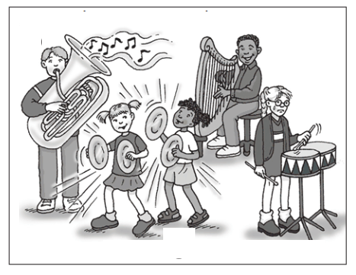**................................................**

**................................................**

**................................................**

**............................... ................**

**................................................**

**7-Rearrange the following sentences: (4 marks)**

➊ **When – concert – school – was – the ?**

**-------------------------------------------------------------------------------------------**

➋**in – What’s – on – going – here ?**

**-------------------------------------------------------------------------------------------**

* **is – behind – There – a – you – box .**

**-------------------------------------------------------------------------------------------**

➍**the soloist – the – tuba – was – Amira – on.**

**8-Punctuate the following sentences. (4 marks)**

**1-can I help you sama**



**2- ali s school is in giza**

[**www.exam-eg.com**](http://www.exam-eg.com)

**موقع الامتحان التعليمى**