Normal Distribution

What is the Normal Random variable?
- A continuous random variable "X" is said to be a normal random variable. If its range is and its probability density function has a bell-shaped curve.
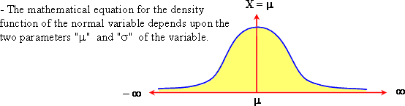
What is the standard normal distribution with
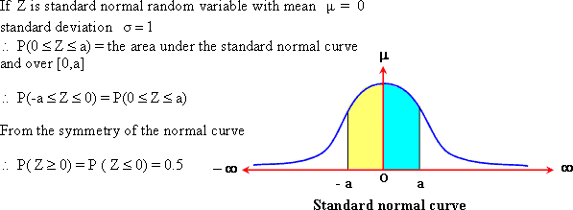
If Z is a standard normal random variable , find:
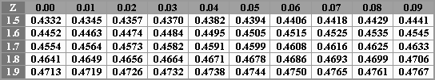

If Z is a standard normal random variable , find:
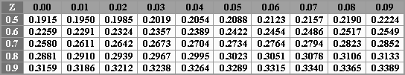

If Z is a standard normal random variable , find:
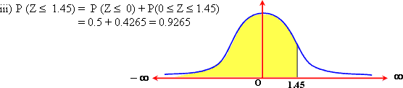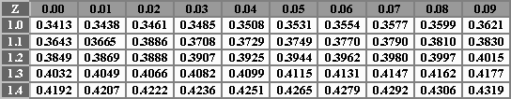

If Z is a standard normal random variable , find:
iv) P(Z≥ -0.84)
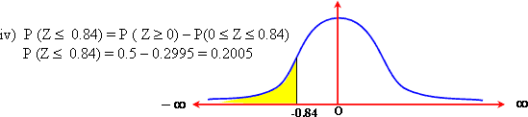

If Z is a standard normal random variable , find:
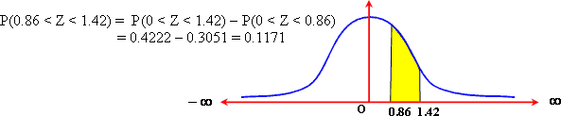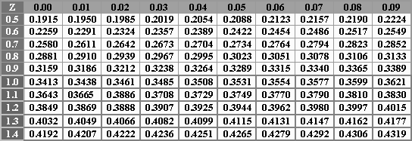

If Z is a standard normal random variable , find:
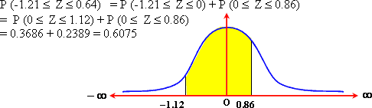
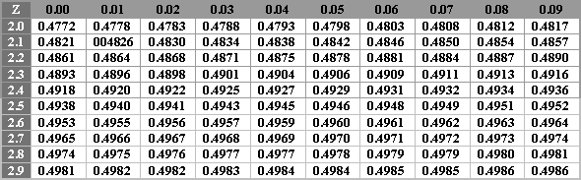

If Z is a standard normal random variable , find:
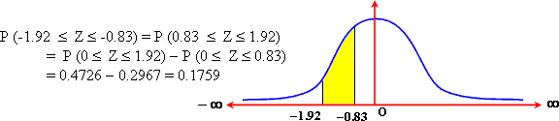

If Z is a standard normal random variable , find:
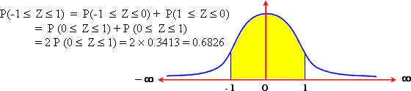

If Z is a standard normal random variable , find:
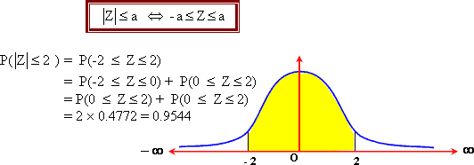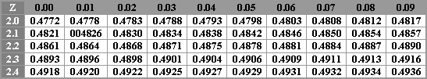

What is the value of the real number k which satisfies:
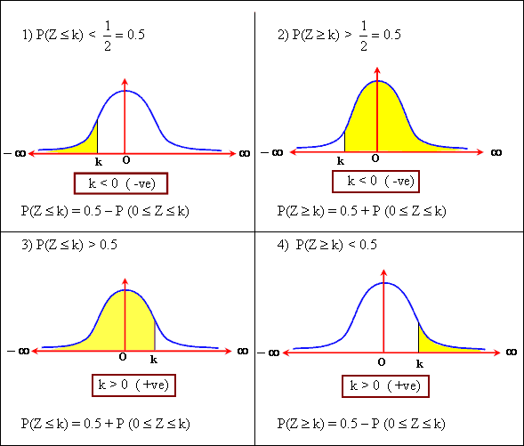

If Z is a standard normal random variable. Find the value of k , if:
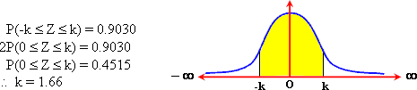

If Z is a standard normal random variable. Find the value of k , if:
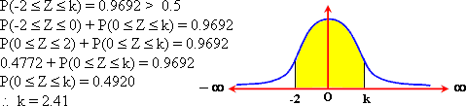

If Z is a standard normal random variable. Find the value of k , if:
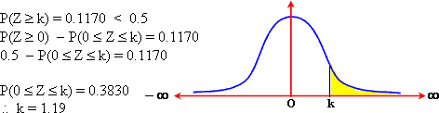

If Z is a standard normal random variable. Find the value of k , if:
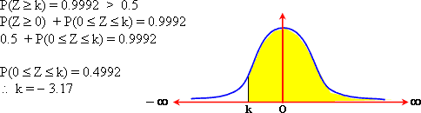
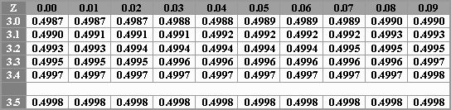

If Z is a standard normal random variable. Find the value of k , if:
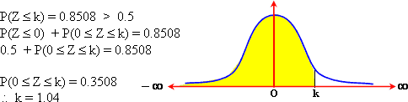

If Z is a standard normal random variable. Find the value of k , if:
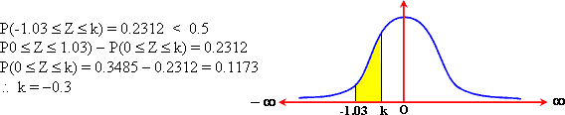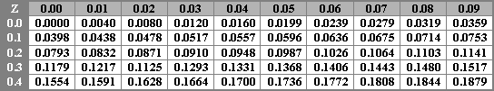

If Z is a standard normal random variable. Find the value of k , if:
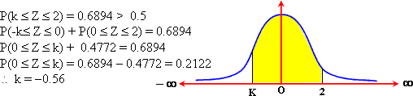

If Z is a standard normal random variable. Find the value of k , if:
If Z is a standard normal random variable. Find the value of k , if:
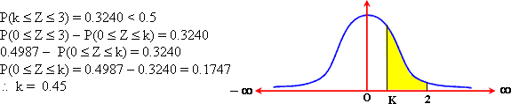

If Z is a standard normal random variable. Find the value of k , if:
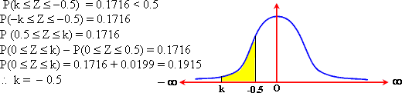

If Z is a standard normal random variable. Find the value of k , if:
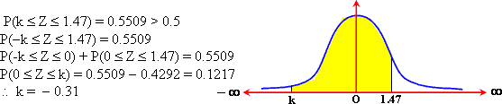

If Z is a standard normal random variable. Find the value of k , if:
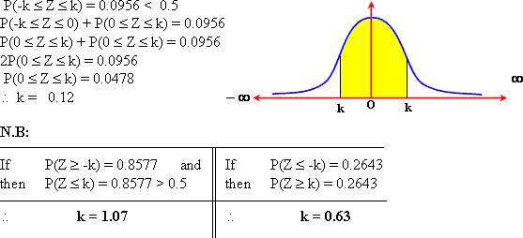

If X is normally distributed with = 50 and variance 100 Find:
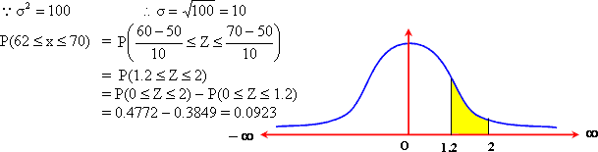
If X is normally distributed with = 50 and variance 100 Find:
