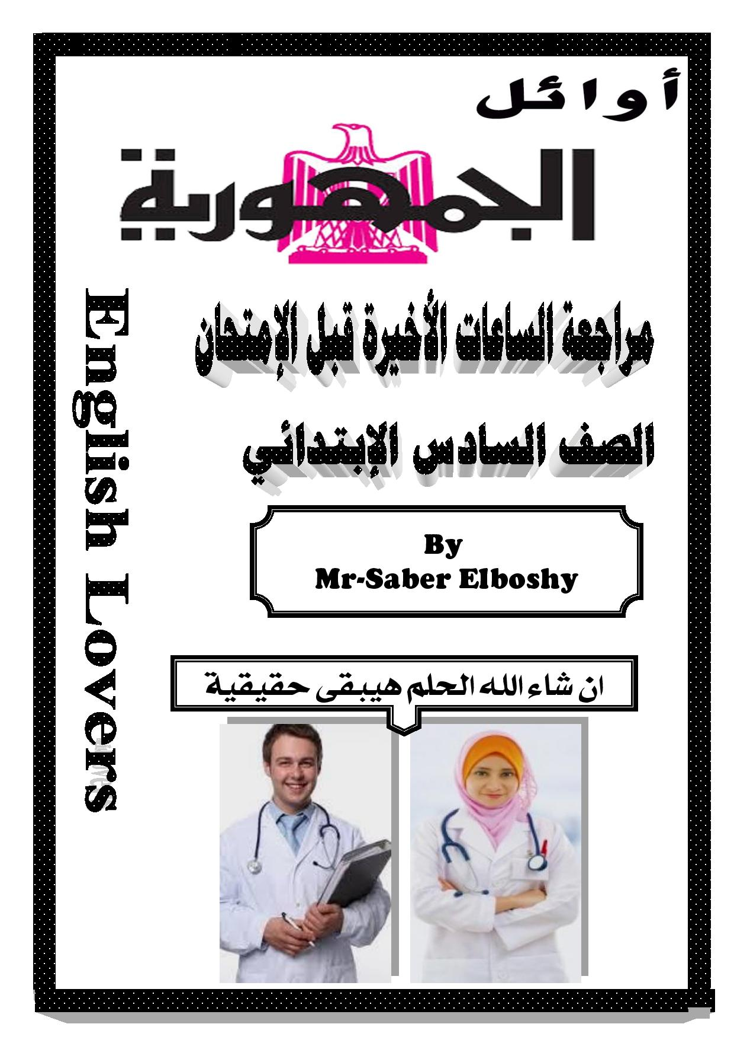

مراجعة الليلة الامتحانية

2- Listen and CompIete.
Huda : Is it the Egyptian museum?
The receptionist :Yes, it .is the Egyptian Museum .
Huda : What hours . are you open? .
The receptionist : We are open daily.
Huda : Thank you for help.
The receptionist : You are welcome.
- Listen and Complete.
Maha : Good morning.
Mother : Good morning.
Maha : May I speak to Mona, please?
Mother : She is not here . right now.
Maha : What time will she be back .?
Mother :I'm sorry, I don't know .
- Listen and complete.
Asmaa : Good morning, Amira.
Amira : Good morning, Asmaa.
Asmaa : How is your sister now?
Amira : She is .fine.
Asmae : Do think that she has the flu ,
Amira : you are right .
3- Choose the correct answer from a, b , c or d:
1- What - are your hours?
a) Where b} What c)How d) Why
2- We are open daily
a) is b) are c) do d) did
3- It's three dollars for adults
a) dollar b) a dollar cldollars d) dollar's
4-1 will take a piece - of apple pie
3) cup b) glass c) piece d) bottle
5- lt looks delicious
a) looks b) look c) looking d) to look
6- How many bottles of water did she have?
a) much b)an c) a d) many
7~ I'm readv to order
a) order b) ordering c) to order d) ordered
8- I'm going to have two glasses of orange juice
a) do b)be c)has d)have
9- How - do you iron your T. shirt?
3) Who b) What c) How d) Which
10- We go to school by - ourselves.
a) myself b) himself c) ourselves d) yourself
11- - May - i help you ?
a) Am b} Are c] Have d) May
12- The car is expensive , it costs a lot of money
a) high b) expensive c)cheap d) bad
13- Where did Bill go yesterday?
3) did in) do c) is d) was
14- My sister doesn't put On make — up.
a) wear b)talk c) drive d) put
15- Does your sister wear a - wig ?
a) cart b)wig c) makeup d)nap
16- She went to the grocer's to buy - groceries.
a) fruits b) groceries c)shirts d) cars
17-- How do you go to a cafe?
a) Who b) What c) How d) How many
18- I take medicine - twice -a day.
a) two b) twice c)to d) too
19- Do you bake bread?
a) bake b) feed c) go d)play
20- It is going to rain.
a) go b) gone c) going d)to go
21-Your brother- loves you very much.
a) loves b) colours c) starts d)adds
6-22-How often . does . she read a newspaper?
a) has b)have c) do d )does
23-In the park, children feed birds.
a) feed b) take c) bake d)visit
24- She reads i a newspaper once a month.
a) is read b) read c) reading d)reads

4 - Circle the odd word and replace it with a correct:
1-swim – eat – sky – play. ( cook )
2- summer – winter – rain – spring . ( fall )
3- herself – yourself – he – myself. (himself )
4- ironed – bought – washed – chop . (chopped )
5- meatballs – steak – salad – juice. (meat )
6-went - chopped-bought – iron . (gave )
7- he - she - we – yourself . ( you )
8-between –under – in – blue . ( on)
9- eat - swim - fly – oranges . ( play )
10- lemon – apple – pie – peach . ( banana)
1l-April - May—June – Sunday ( july )
12-English -- Math – underground - Arabic . ( art )
13-hot - cold - warm – start. ( cool)
14-plane — bus — bike – three. ( car)
15-soup – bread- meat – pie. ( fish)
5-Read the passage and answer the Questions:
Last weekend , All went to the amusement park , He had an orange juice. He went on a ride . He saw a dolphin show . He ate cookies, He took some pictures. He was very happy . His family was with him to keep an eye on him. His father does his best to make him happy. His mother also want him to be happy. He wanted to be a doctor when he grows up .
A-Choose the correct answer from a, b , c or d:
l-Ali was ……. happy
a) sad b) happy c) tired d) ill
2-Ali drank an orange juice.
a} apple b) lemon c) an orange d) pie
B-Answer the following Questions:
3—Where did Ali go at the weekend?
He went to the amusement park.
4-What did he see?
He saw a dolphin show .

Read the passage and answer the Questions.
Over 30 million people visit New York every year. It is a beautiful city. There are thousand restaurants .There are also many shops. You can see many nice buildings there .Tours there are found everywhere. I was there years ago. I saw many tall buildings there . I made many friends there . The people there are very welcoming .
A-Choose the correct answer from a, b or c:
1-There are many nice buildings in New York.
a) ugly b) bad c) old d) nice
2-You can buy there from shops there.
a) shops b) tours c) homes d) museums
B-Answer these Questions:
3-Why do people go to New York?
Because it is a beautiful city.
4-What did the writer make when he was there ?
He made many friends.
-5- Read the gafige and answer the Questions.
There is a boy in our class at school. His name is Ali. He follows us all the time and always bothers us. He takes our things without asking. Our teachers told us to be patient. It is not fair. We hate boys like him .We should be honest and fair.
A- Choose the correct answer from at b, c or d:
-1 Ali is a bad boy.
a)bad b) nice c) cute d) fair
-2 It is not fair for the class to be patient
a) fair b)not fair c) nice d) good
B- answer these guestions:.
-3-What is the name of the boy ?
His name is Ali
4-How should we be?
We should be honest and fair

-6 Write a letter of FOUR sentences:
Write a letter to yourfriend Hala telling her about the lunch you have ata restaurant. Your name is Salwa and you live at 3 El Tahrir street , Cairo
3 El Tahrir street
Cairo
15 th January, 201 7
Dear, Haha
Hello. How are you and your family ?I'm very happy to write to you this letter . I have lunch with my family at a restaurant The food is delicious . I eat fish and rice . The restaurant is clean . They serve lunch and dinner. Write me soon
Yours
Salwa
6-Look and write a pa ragragh of FOUR {4] sentences about the picture

Egypt is a nice country. I live in Cairo . This is our
River Nile . It is our life . I like Egypt very much .
It is a beautiful country.

6 -Write a letter of FOUR sentences.
Write a letter to your friend telling him that your sister is ill . She has a flu in the hospital . Your name is Hany and you live at 5 Abou Keer street, Alex
5 Abou Keer
Alexandria
15'" January, 2017
Dear; Friend

Hello. How are you and your family ?I'm very happy to write to you this letter. I want to tell you that my sister is ill . She has a flu . She is in the hospital . It is not serious . I hope she will be fine .See you soon.
Yours
Hany
المذاكرة فن و تنظيم ... مش هز اكتاف
والنهائية سهر وتعب ... مش نوم تحت اللحاف

6- Rearrange the following words to make correct serntences :
1 — English - us — have — with — Study - fun - and.
Study English with us and have fun .
2 - Tomorrow - the - What’s - for - homework?
What's the homework for tomorrow?
3 - in - opened - factory - 1851 - The - first - cream - ice-
The first ice cream factory opened in 1851 .
4 - there - Is - beside - your - bank - a - house?
Is there a bank beside your house ?
5 - laundry - themselves - can - They - do - by.
They can do laundry by themselves .
6 - you - any - Do - pies - have - cherry?
Do you have any cherry pies ?
7 - home - stayed - tuesday - l - on.
I stayed home on Tuesday.
8 - he - What - time - will - back - be?
What time will he be back ?
9 - visited - library - yesterday - ME - Alexandria-
We visited Alexandria Library yesterday .
10 - ol‘len - you - How - read - newspaper - a - do?
How often do you read a newspaper ?
11 - years — am — thirteen - l — old-
lam thirteen years old .
12 - an - lg - in - uyour - underground - there - town?
Is there an underground in your town ?
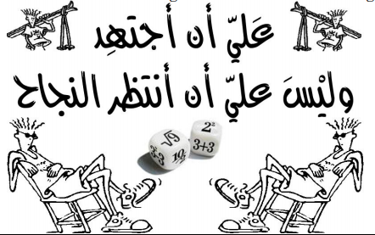

منتدى الامتحان التعليمى

www.exam-eg.com

